Environmental monitoring

Definition:

Environmental monitoring involves the systematic collection and analysis of data to assess and understand changes in the environment. It helps track air and water quality, biodiversity, pollution levels, and more to make informed decisions and protect ecosystems. How can I assist you further with environmental monitoring?

Solving environmental monitoring problems often requires a multi-faceted approach. Here are some general steps to address such issues:

* **Identify the Problem:** Clearly define the environmental issue you're addressing, such as air pollution, water contamination, or habitat degradation.
* **Data Collection:** Gather accurate and reliable data through sensors, surveys, and scientific studies. High-quality data is essential for informed decision-making.
* **Analysis:** Analyze the collected data to understand the problem's scope, trends, and potential causes. Statistical tools and modeling can help with this.
* **Stakeholder Engagement:** Involve relevant stakeholders, including government agencies, NGOs, local communities, and industry representatives, to ensure a collaborative and holistic approach.
* **Regulatory Compliance:** Ensure that monitoring activities comply with relevant environmental regulations and standards.
* **Technology and Innovation:** Utilize advanced technologies such as remote sensing, IoT, and AI for efficient data collection and analysis.
* **Mitigation Strategies:** Develop and implement strategies to mitigate or prevent further environmental damage. This could include policy changes, improved industrial practices, or habitat restoration.
* **Public Awareness:** Raise public awareness about the issue to garner support and encourage responsible behavior.
* **Long-Term Monitoring:** Establish continuous monitoring systems to track changes and assess the effectiveness of mitigation efforts over time.
* **Adaptation:** Be prepared to adapt strategies as new data and insights emerge or as environmental conditions change.
* **Funding and Resources:** Secure necessary funding and resources to sustain monitoring and mitigation efforts.
* **Collaboration:** Collaborate with other organizations, research institutions, and experts to benefit from their knowledge and resources.
* **Evaluation:** Periodically evaluate the effectiveness of your solutions and adjust them as needed.

Remember that specific environmental problems may require tailored approaches, and it's crucial to work in harmony with the local context and the unique challenges it presents.

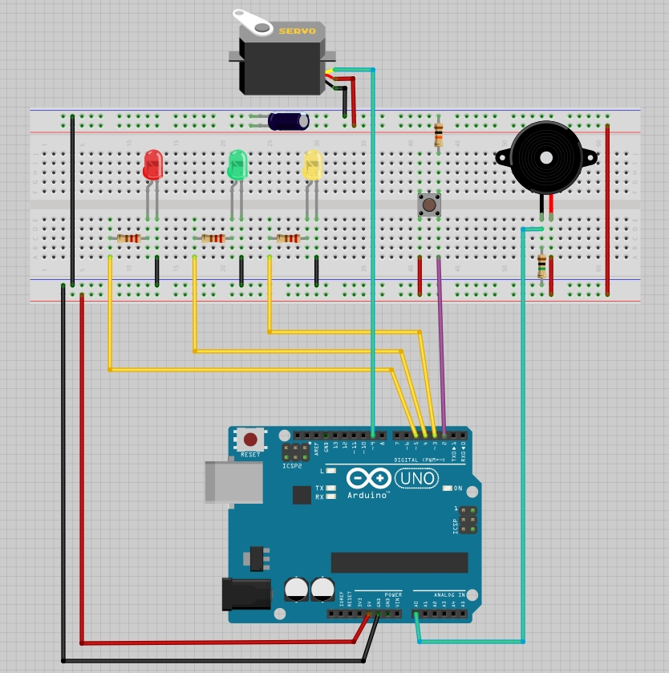**Figure: Environmental monitoring**